**Lab Program: 04**

**Execute the fallowing queries:-**

**a. How the resulting salaries if every employee working on the ‘Research ‘Departments is given a 10% raise.**

**b. Find the sum of the salaries of all employees of the ‘Accounts’ department, as well as the maximum salary, the minimum salary, and the average salary in this department.**

**Consider the Company database with following schema.**

**Step 1:-**

**DEPT (DNO: integer; DNAME: varchar; DLOCATION: varchar)**

**SQL> Create table DEPT**

**(DNO int (4) primary key,**

**DNAME varchar (20) Not Null,**

**DLOCATION varhcar (20));**

**Table created**

**Execution:-**

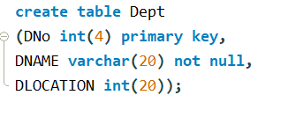

**SQL> Desc DEPT;**

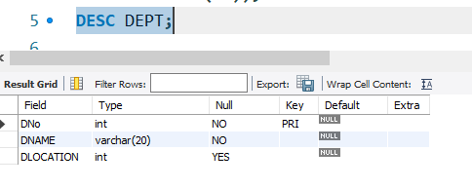

**Step 2:-**

**EMP (ENO: integer; ENAME: string; EBDATE: Date; ADDRESS: Text; GENDER: text; SALARY: int; DEPTNO: int)**

**SQL> Create table EMP**

**(ENO int (6) primary key,**

**ENAME varchar (20) Not Null,**

**EBDATE date,**

**ADRESS varchar (20),**

**GENDER char (3),**

**SALARY int (10) not null,**

**DNO int (4) references dept);**

**Table created**

**Execution:-**

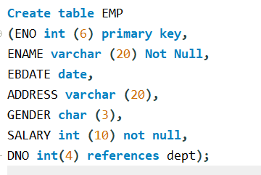

**SQL> Desc EMP;**

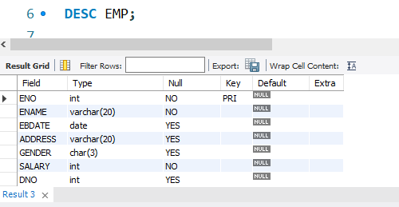

**Step 3:- PROJECT (PNO: int; PNAME: string; DNUM: int)**

**SQL> Create table PROJECT**

**(PNO int (10) primary key,**

**PNAME varchar (20) Not Null,**

**DNO int (4) references DEPT);**

**Table created**

**Execution:-**

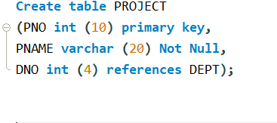

**SQL> Desc PROJECT;**

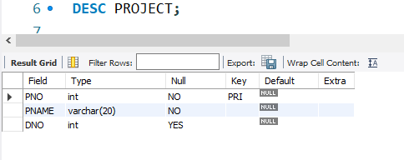

**Step 4:- WORKS_ON (ENO: int; PNUM: int; HOURS: int)**

**SQL> Create table WORKS_ON**

**(ENO int (6) REFERENCES EMP Not Null,**

**PNO int (10) REFERENCES PROJECT Not Null,**

**HOURS float (3, 1),**

**Primary key (ENO, PNO));**

**Table created**

**Execution:-**

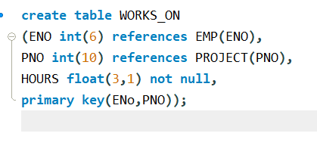

**Step 5:-**

**Insert into dept (DNO, DNAME, DLOCATION) values (2,’ACCOUNTS’, JAYANAGAR’);**

**1 rows created.**

**Insert into dept (DNO, DNAME, DLOCATION) values (4,’RESEARCH’, KENGERI’);**

**1 rows created.**

**INSERT INTO DEPT (DNO, DNAME, DLOCATION) values (5,'ADMIN','SOUTHEND');**

**1 rows created.**

**Execution:-**

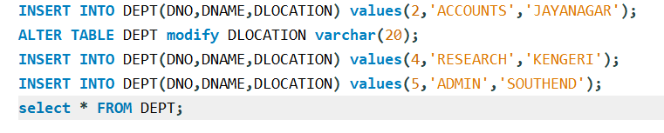

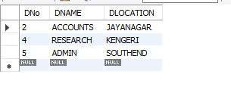

**Step 6:-**

**INSERT INTO EMP (ENO,ENAME,EBDATE,ADDRESS,GENDER,SALARY,DNO)**

**Values (1001,'ANIRUDH','1990-01-14','BANGALORE','M', 45000, 4);**

**Execution:-**

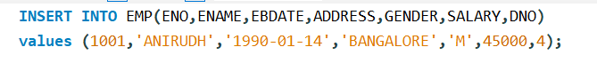

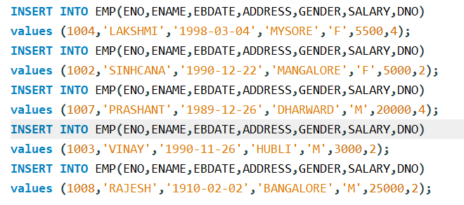

**Note: - Enter this values into the table EMP as shown below**

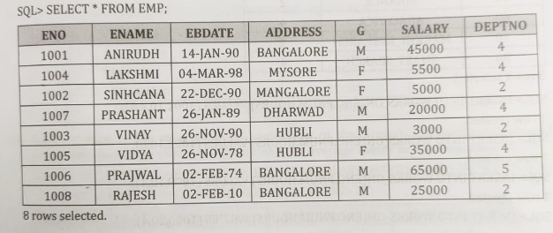

**Step 7:- INSERT INTO PROJECT (PNO, PNAME, DNO)**

**Values (20,'ERP', 5);**

**Execution:-**

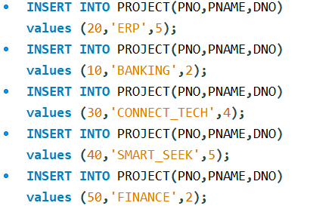

**Note: - Enter this values into the table EMP as shown below**

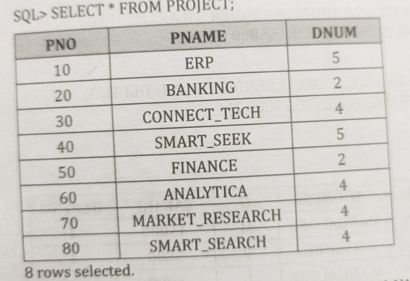

**Step 8:- INSERT INTO works_on (ENO, PNO, HOURS)**

**Values (1001, 10, 4.5);**

**Execution:-**

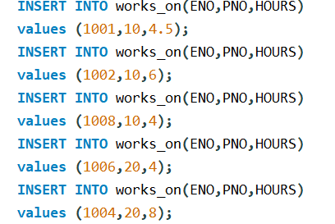

**Note: - Enter this values into the table EMP as shown below**

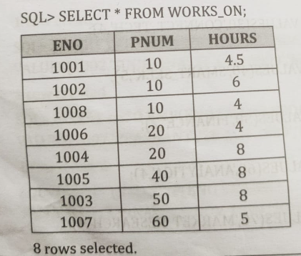

**Execute the Following Queries:**

1. **How the resulting salaries if every employee working on the ‘Research’ Department is given a 10 percent raise.**

**SQL> SELECT E.ENO,E.ENAME,D.DNAME,1.1*E.SALARY AS "INC_SALARY"**

**FROM EMP E,DEPT D**

**WHERE E.DNO=D.DNO AND D.DNAME='RESEARCH';**

**Execution:-**

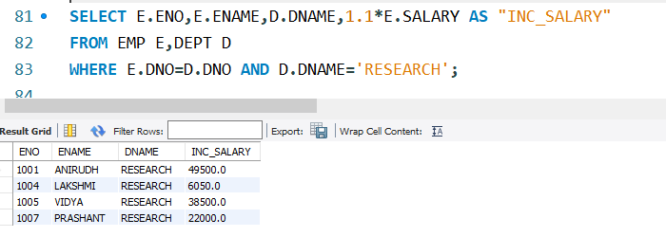

**(b) Find the sum of the salaries of all employee of the ‘ACCOUNTS’ department , as well as the maximum salary, the minimum salary, and the average salary in this department.**

**SQL>**

**Select max (E.SALARY), MIN (E.SALARY), SUM (E.SALARY), AVG (E.SALARY)**

**FROM EMP E, DEPT D**

**WHERE E.DNO=D.DNO AND D.DNAME='ACCOUNTS';**

**Execution:-**

